Request of update for the public website
  - 03/10/2016

Current structure
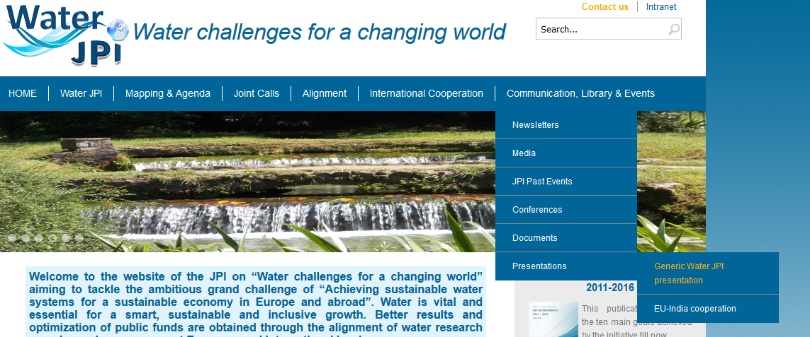
Could you please replace the existing presentation available on the Water JPI website at http://www.waterjpi.eu/images/WaterJPI/generic%20water%20jpi%20presentation_20151207_short.pdf) in the “Communication, Library & events / Presentations / Generic Water JPI presentation” subtab by a new one (see attachment)?

New structure
Same structure, just replace the pdf link with the pdf file enclosed in the email

