INSTRUCTIONS FOR DRAFTING THE SCIENTIFIC CONTENT OF YOUR PRE-PROPOSAL (PART B)
The scientific content of this pre-proposal (Part B) must be submitted electronically, using the electronic submission service accessible from the 2016 Joint Call Official webpage. The Pre-Proposal Part B is submitted by the Consortium Coordinator.

Table of Contents

How to complete Part B 2
Part B – Template Document 3

How to complete Part B
Part B of the proposal contains the details of the proposed research and collaborative efforts. At the pre-proposal stage, the practical arrangements planned to implement the proposal (this will relate to the Quality and Efficiency of the Implementation Section of the Full Proposal at second stage) will not be evaluated by the independent experts. We would advise you to address each of the award criteria as outlined in the following sections. Please note that the explanatory notes below serve to explain the evaluation criteria without being exhaustive.
Applicants must structure their proposal according to the headings indicated in the Part B pre-proposal template below.
Applicants must ensure that their pre-proposals conform to the layout and to the instructions given on this page. The maximum total length of sections 1 to 3 of Part B of the proposal is 5 pages. Taken into consideration that the overall document will have one page for the cover and one page for the table of contents, the overall page count must be 7 at maximum.
There is no specific page limit per each individual section of Part B. Within the overall five-page limit, applicants are therefore free to decide on the length dedicated to each section.
Please remember that it is your responsibility to comply with the page limit and all other formal eligibility criteria. Proposals not meeting all these criteria will be declined without further review.
The page size is A4, and all margins (top, bottom, left, right) should be at least 15 mm (not including any footers or headers). This document has the correct format and font. Use this as your starting document and delete where appropriate. Use the same font and style for the whole proposal (Times New Roman, 11 pt, single spacing).
Literature references should be listed in footnotes, font size 9. However, regardless of the format used, all footnotes will count towards the page limit.
Please make sure that the Part B of your proposal carries as a header to each page the proposal acronym. All pages should be numbered in a single series on the footer of the page to prevent errors during handling. The numbering format "Page X of Y" should be used.

Part B
(Delete as appropriate, and include Proposal Title and Acronym in the bottom of the page)
ERA-NET COFUND WATERWORKS2015
  - Joint Programming Initiatives
  - Water Challenges for a Changing World
  - Agriculture, Food Security and Climate Change
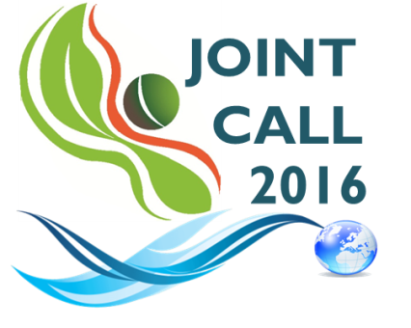

“PROPOSAL FULL TITLE”
“PROPOSAL ACRONYM”

Table of Contents

In drafting PART B of the proposal, applicants must follow the structure outlined below. (Delete as appropriate)

START PAGE COUNT
- SUMMARY
- EXCELLENCE
- IMPACT
STOP PAGE COUNT

IMPORTANT:
Applicants must ensure that sections 1-3 do not exceed the limit of 5 pages

START PAGE COUNT
1. PROJECT SUMMARY
Please provide a short summary of the proposal, which can be the same as the publishable abstract, built around the research/innovation project.
2. EXCELLENCE
This section is intended to evaluate the quality, innovative aspects and credibility of the research, including inter/multidisciplinary aspects. The following subtopics should be included:
- Introduction
- State-of-the-art
- Objectives and overview of the action (The specific objectives for the project should be clear, measurable, realistic and achievable within the duration of the project. Objectives should be consistent with the expected exploitation and impact of the project)
- Relation to the scope of the call (Clearly inficate wich challenge(s) and sub-topic(s) your proposal is addressing and explain how your proposal addresses the specific challenge and scope of that topic, as set out in the Call description.)
- Work package description (including research methodology and approach, highlighting the type of research and innovation activities proposed)
- Originality and innovative aspects of the research (explain the contribution that the project is expected to make to advancements, including novel concepts, approaches or methods employed)
3. IMPACT (topics to be included are described below):
This section is intended to evaluate the impact of the research project. The following subtopics should be included:
- Expected Outcomes and impact of the research ((i) Describe how your project will contribute to: (a) each of the expected impacts mentioned in the Call Announcement, under the relevant topic; (b) any substantial impacts not mentioned in the Call Annoucement, that would enhance innovation capacity; (ii) Describe any barriers/obstacles, and any framework conditions (such as regulation, standards, public acceptance, workforce considerations, financing of follow-up steps, cooperation of other links in the value chain, that may determine whether and to what extent the expected impacts will be achieved.)
- Exploitation (All applicants should ensure that the results of their project are disseminated and exploited, e.g. communicated, transferred into other research/innovation settings or, if appropriate, commercialised).
- Added-value of the partnership to Water RDI
END PAGE COUNT

